

|  |
| --- |
| **Faculty of Computing and Information Technology** |
| **Assignment**  **May 2021 Semester** |
| **Course code :** AACS3064  **Course Title :** Computer Systems Architecture |
| |  |  |  |  | | --- | --- | --- | --- | | **Students’ Name &** | **:** | Name: Har Chun Wai | ID. No.: 20WMD02982 | | **ID No.** |  | Name: Tan Kang Hong | ID. No.: 20WMD02959 | |  |  | Name: Lau Jun Dian | ID. No.: 20WMD03133 | |  |  | Name: Ho Jing Xian | ID. No.: 20WMD02895 |  |  |  |  |  | | --- | --- | --- | --- | | **Programme\*** | **:** | DFT2/DCO2/DCN2/DSF2 | **[* Circle whichever is appropriate.]** | | **Tutorial Group** | **:** | 5 |  | | **Tutor** | **:** | Chong Jing Wen |  | | **Submission Date** | **:** | **Week 12, Friday, before 12 noon** |  | |
| |  |  |  |  | | --- | --- | --- | --- | | **Members’**  **Name** | **Part 1** | **Part 2** | **Total** | | **(20 marks)** | **(80 marks)** | **(100 marks)** | | **1) Har Chun Wai** |  |  |  | | **2) Tan Kang Hong** |  |  |  | | **3) Lau Jun Dian** |  |  |  | | **4) Ho Jing Xian** |  |  |  | | **Comments:** | | | | | **Date of submission :** |  | | | | **Date received :**  **(to-be filled by the tutor received)** |  | | | |

Semester: 1 Course Code & Title: AACS3064 Computer Systems Architecture

**Declaration**

**I/We confirm that I/we have read and shall comply with all the terms and condition of TAR University College’s plagiarism policy.**

**I/We declare that this assignment is free from all forms of plagiarism and for all intents and purposes is my/our own properly derived work.**

**I/We further confirm that the same work, where appropriate, has been verified by anti-plagiarism software Plagiarism Detector *(please insert).***

Signature(s): Wai Tan DIan Xian [By all members]

Name(s): Har Chun Wai Tan Kang Hong Lau Jun Dian Ho Jing Xian [By all members] Date:

# Assignment

Assessment Rubrics

|  |  |  |  |  |  |  |
| --- | --- | --- | --- | --- | --- | --- |
| **CLO2 – Demonstrate effective team skill in constructing a program using assembly language (A2,PLO4) PART A1 (20%)** | | | | | | |
|  |  | **Poor** | **Fair** | **Average** | **Good** | **Excellent** |
|  | **Marks** | **0 - 2** | **3 - 4** | **5 - 6** | **7 - 8** | **9 - 10** |
| **Ability to generate clearly written proposal** | **10** | Incomplete proposal | Proposal with limited information and incorrect  flow chart | Proposal with basic information and correct  flow chart | Proposal with added information and correct  flow chart | Proposal with comprehensive details and flow chart |
|  | **Marks** | **0 - 3** | **4 - 7** | **8 - 10** |  |  |
| **Accountability for assigned tasks (Teamwork)** | **10** | Individuals work on different tasks of the assignment but do not collaborate to bring the diverse parts together. | Individuals work on different task of the assignment, with a coordinator (or coordinators) who connects the separate pieces together (i.e., they rely on the sum of each  individual's best effort). | The assignment is the result of a collaborative effort; team members are individually and jointly responsible for the successful fulfilment of their tasks. |  |  |
|  | | | | | | |
| **PART A2 (80%)**  **CLO3 – Construct a program using assembly language. (P3, PLO3)** | | | | | | |
|  | **Marks** | **0 - 5** | **6 - 10** | **11 – 15** | **16 - 20** | **21 – 25** |
| **Functionality** | **25** | Unable to provide all the required functionalit  y. Program does not work  correctly | Unable to provide all the required functionality. Several functions of program does | Able to provide all the required functionality. Some functions of program does | Able to provide all the required functionality. Program does work correctly | Provided all the required functionalities and they work excellently |

|  |  |  |  |  |  |  |
| --- | --- | --- | --- | --- | --- | --- |
|  |  |  | not work  correctly | not work  correctly |  |  |
|  | **Marks** | **0 - 7** | **8 - 14** | **15 - 21** | **22 - 28** | **29 - 35** |
| **Level of difficulty** | **35** | Program is very simple to implement | Program is simple to implement | Program has moderate difficulty to implement | Program is challenging to implement | Program is very challenging to implement |
|  | **Marks** | **0 - 2** | **3 - 4** | **5 – 6** | **7 - 8** | **9 – 10** |
| **User friendliness & integration** | **10** | Ambiguous feedback and help. Minimal exception handling and error messages and the system modules are not  integrated. | Some feedback, useful help, and error checking features are provided with minimum integrated system modules. | Some feedback, useful help, and error checking features are provided with average integrated system modules. | Clear feedback, useful help, and error checking features are provided with integrated system modules. | Clear feedback, useful help, and error checking features are provided with integrated system modules. |
|  | **Marks** | **0 - 2** | **3 - 4** | **5 – 7** | **8- 10** |  |
| **I/O design** | **10** | Poor / brief in input/output design | Proper but simple input/output design. | Effective and efficient input/output design. | Consistent, effective and efficient input/output design. |  |

**Table of Contents**

|  |  |
| --- | --- |
| **Title** | **Page** |
| **Table of Contents** | **5** |
| **Chapter 1: The Proposal** |  |
| 1.1 Industry selected | 6 |
| 1.2 Company background | 6-7 |
| 1.3 Propose Functions to be included | 7 |
| 1.4 Propose Formulas used | 8 |
| 1.5 Assumptions | 8 |
| **Chapter 2: Flow chart** | **9-10** |
| **References** | **11** |

# The Proposal

## **1.1 Industry selected**

The hotel industry may be part of this industry, involving guest accommodation or accommodation. Although there is a significant difference in scope, it is closely related to the tourism and hospitality industries. In this assignment, we mainly refer specifically to the hotels.

## **1.2 Company background**

The CKJ Hotel and Resorts, which opened its first hotel in 1969, is a tale of continual innovation, remarkable expansion and single-minded dedication to the highest of standards. This Malaysian-based company has, for 60 years, transformed the hospitality industry by combining personalized, genuine care with an unwavering commitment to excellence. In the process, CKJ has redefined luxury for the modern traveler.

Architect Bill Bensley, who designed CKJ hotel, had no plans to enter the hotel business on a grand scale when the young architect and builder – working with the boss of CKJ Hotel (Tan Sri Kwok Kuai An), constructed his first hotel. Over the course of this decade, he opened ten CKJ hotels around the world. Kwok experience would pave the way for the creation of a new kind of hotel, one focused solely on the guest.

The 1970s began with a defining moment – the opening of a hotel in Kuala Lumpur, Malaysia. This hotel set the tone for the future direction of the company and pioneered many of the signature CKJ services now delivered worldwide. Within a few years, the company portfolio also included 12 hotels across the world.

CKJ as a distinct brand name was coming into its own. Divesting less-strategic properties, the company began to transform itself from a hotel owner-operator into a management company. It also started to manage hotels in mixed-use developments, a new concept at the time, allowing it to extend its expertise into high-quality residential environments.

CKJ continued its focus on global expansion, while maintaining its emphasis on creativity and innovation, both through the introduction of new properties and technologies, ultimately enhancing its leadership in luxury travel. CKJ pays attention to cooperation with other hotel companies, and achieves company benefits through mutual benefits.

Entering the current decade, CKJ continues to work through the unprecedented challenges brought about by the COVID-19 pandemic. In response, CKJ launched its enhanced health and safety program, “Lead with Care”, continuing to build upon the trust, care and flexibility that the company has long-established with its guests and residents. Despite this circumstance, CKJ continues to focus on exceptional service, maintaining its development momentum with new projects in key markets and solidifying its place in the future of luxury hospitality.

## **1.3 Propose Functions to be included**

* Room reservation - This allows the customers to choose the type of room according to their preferred number of adults and child before the upcoming date.
* Waterfront voucher - This function is used for extra discounts for certain charges.
* Catering services – This function is responsible for extra reservation charges.
* Members-only discounts – Customers who have their member card can enjoy extra discounts.
* Currency exchange – Customers can choose to pay with RM or USD
* Car parking – Allow customers to park their own vehicles at the parking garage during their reservation days.
* Member registration – This allows customers to register as a member, so they can enjoy the discounts provided in future reservations.

## **1.4 Propose Formulas used**

* Room reservation -> 1st day: RM75, for each subsequent day: RM30

E.g.: Room reservation for 5 days => 75 + (30 * 4) = RM195

* Waterfront voucher -> 10% discount on room reservation charges

E.g.: Room reservation for 5 days with waterfront voucher => 195 * 0.9 = RM175.50

* Catering services -> extra RM15 per adult, RM10 if child

E.g.: Catering service for 2 adults and 1 child => (15 * 2) + (10 * 1) = RM40

* Members-only discounts -> 3% discount on subtotal

E.g.: Assume subtotal is RM235, if customer has a member card => 235 * 0.97 = RM227.95

* Currency exchange -> 1 USD = RM4

E.g.: Assume subtotal is RM235, if the customer wants to pay with USD => 235 / 4.23 = $55.56

* Car parking -> RM2 per day

E.g.: 3 days for Car parking => 2 * 3 = RM6

* Member registration -> RM50 for customers who want to register as a member

## **1.5 Assumptions**

* Assume that the currency exchange rate for 1 USD is equal to RM4
* Assume that the currency exchange only involves two currencies (USD and RM)

# Flow chart

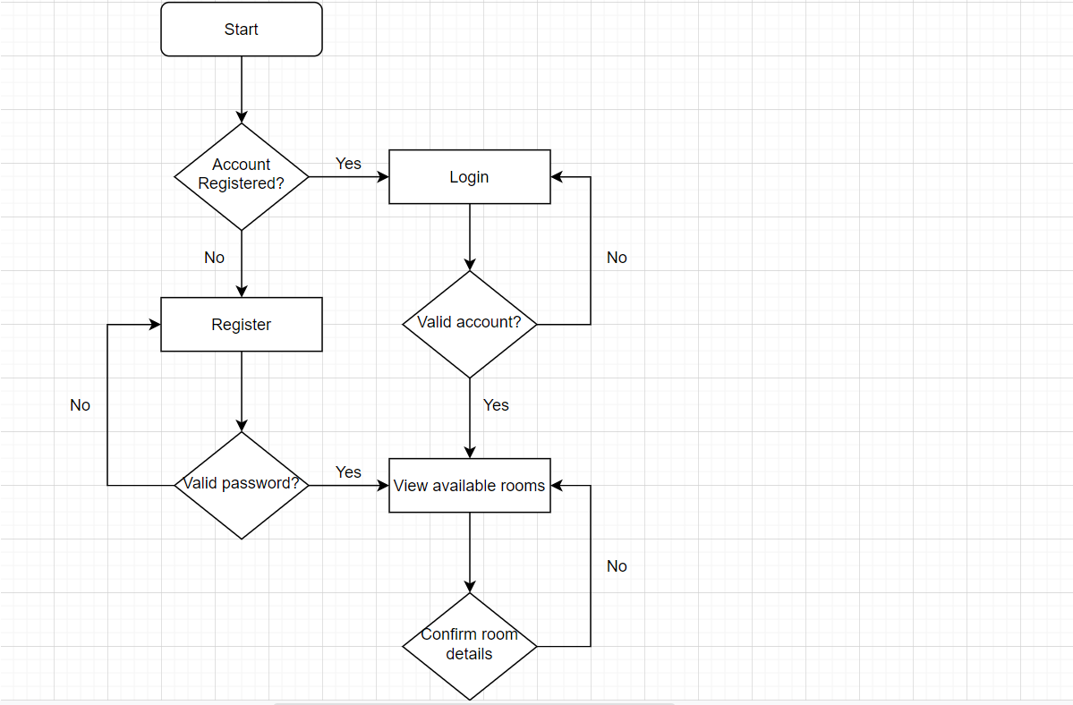

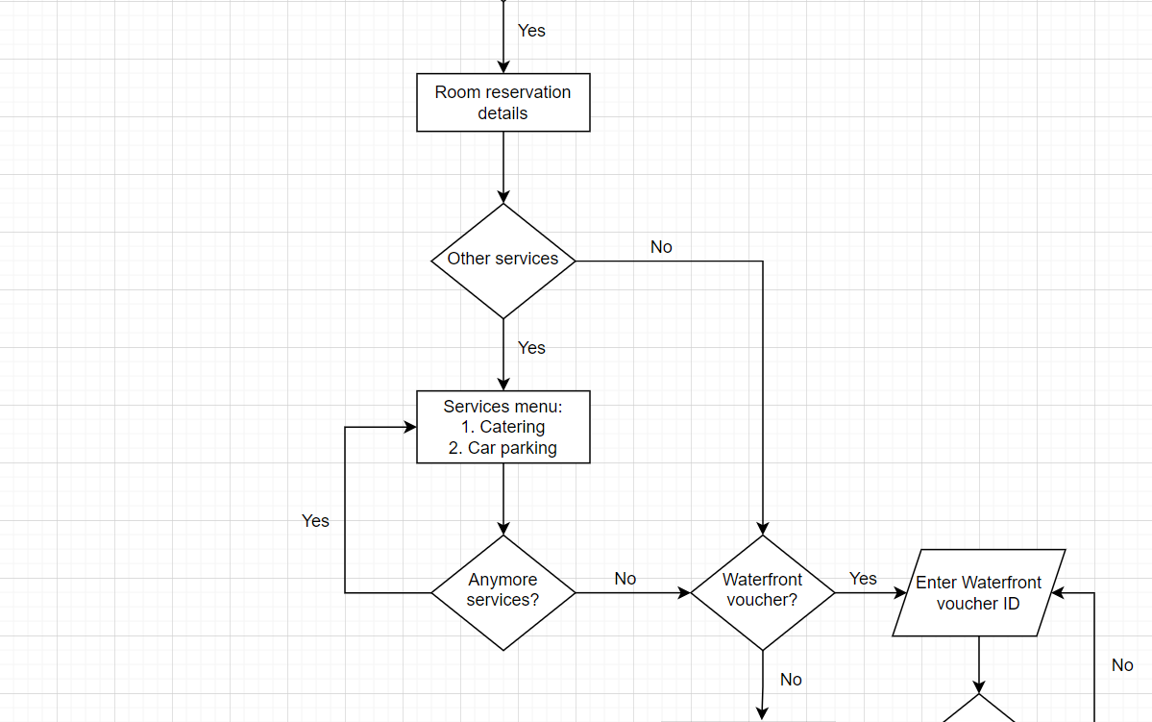

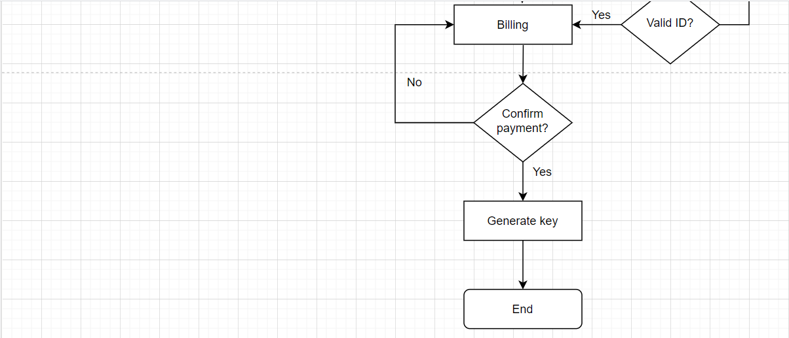

# References

1. Revfine.com. Hotel Industry: Everything You Need to Know About Hotels! [online] Available at: <https://www.revfine.com/hotel-industry/> [Accessed 20 July 2021]
2. Four Seasons. Four Seasons History. [online] Available at: <https://www.fourseasons.com/about_four_seasons/four_seasons_history/> [Accessed 21 July 2021]